1: Q1.1

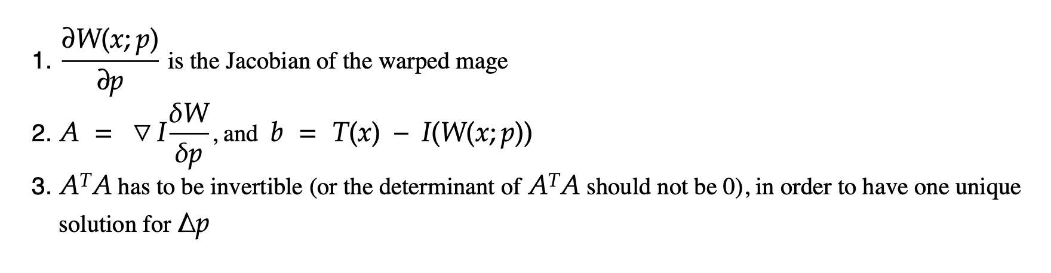

2: Q1.2

Algorithm implemented.

**Note**: that the it takes approximately 20 mins for me, using my code, to finish tracking all the frames.

3: Q1.3

Tracking using Lucas-Kanade algorithm at frame 1, 100, 200, 300, 400.

Note: that the it takes approximately 20 mins for me to finish tracking all the frames.

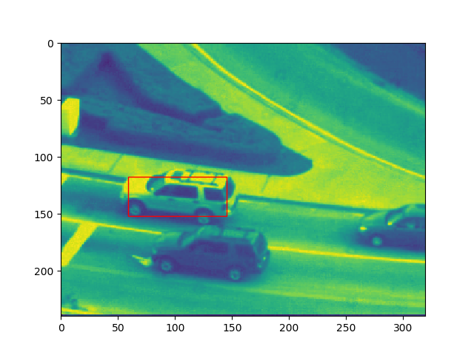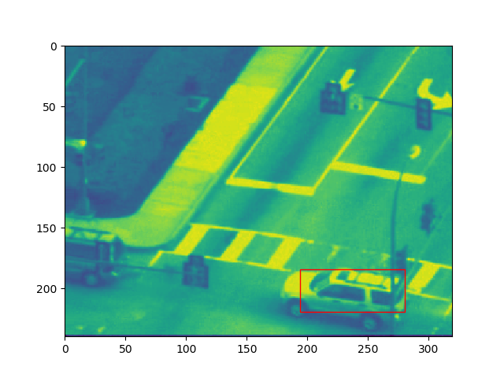

*figure 1.3.1 Frame 1 and 100 using Lucas-Kanade (without template drifting correction)*

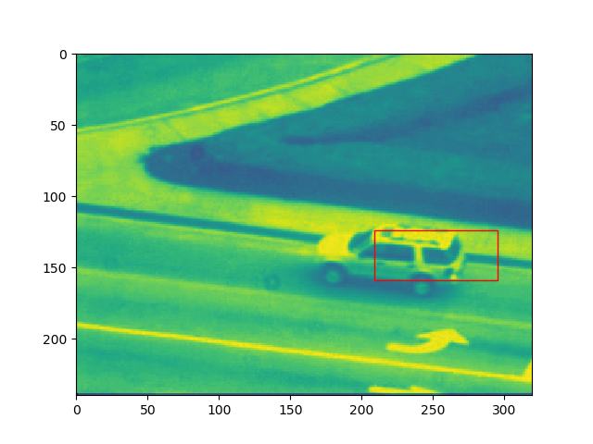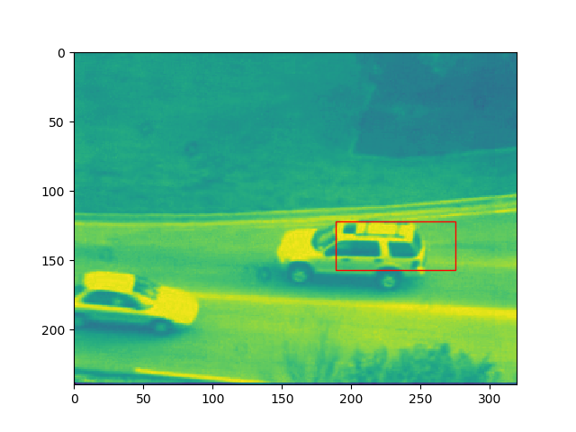

*figure 1.3.2Frame 200 and 300 using Lucas-Kanade (without template drifting correction)*

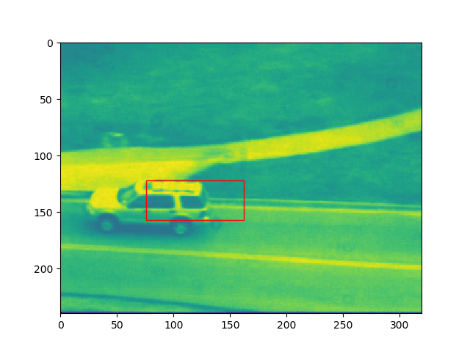

*figure 1.3.3 Frame 400 using Lucas-Kanade (without template drifting correction)*

4: Q1.4

Note: that the it takes 20+ minutes for me to finish tracking all the frames.

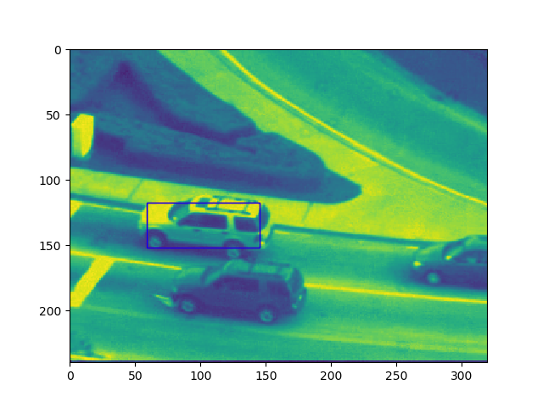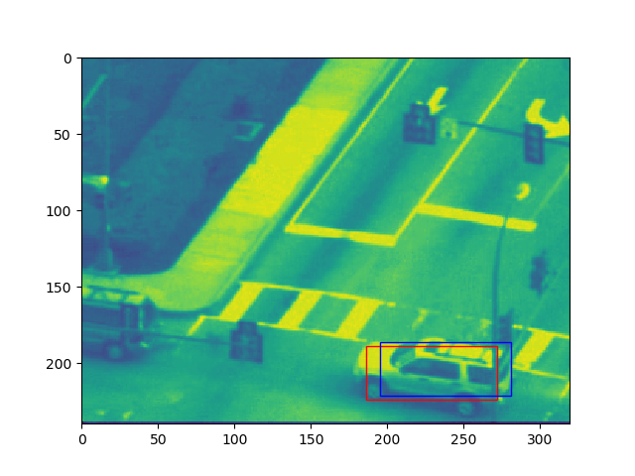

*figure 1.4.1 Frame 1 and 100 using Lucas-Kanade using template drift comparison (red) in comparison with no correction (blue)*

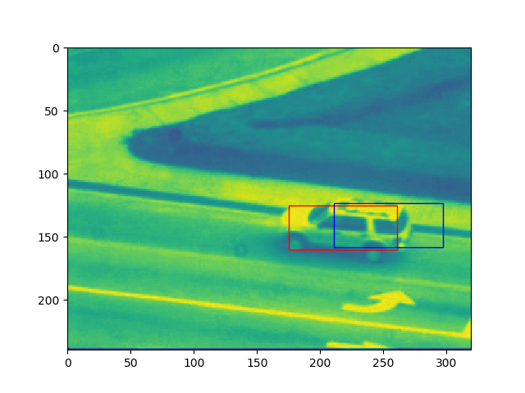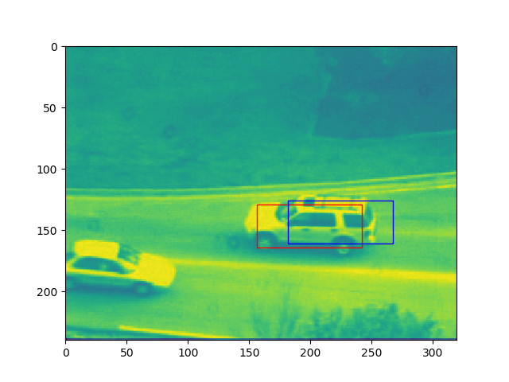

*figure 1.4.2 Frame 200 and 300 using Lucas-Kanade using template drift comparison (red) in comparison with no correction (blue)*

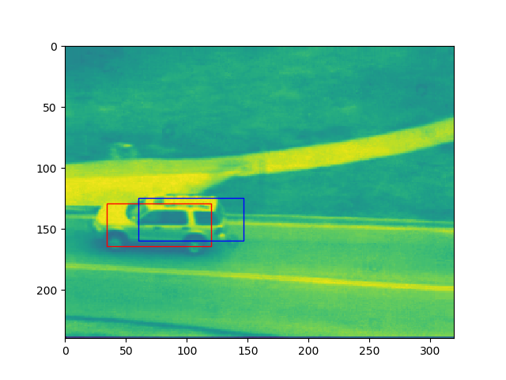

*figure 1.4.3 Frame 400 using Lucas-Kanade using template drift comparison (red) in comparison with no correction (blue)*

5: Q2.1

According to the paper “Lucas-Kanade 20 Years on:…. Part 2”

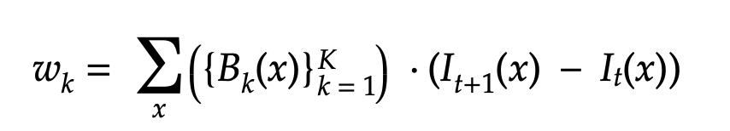

where wi is the scalar weight for each orthobasis Bk.

If we are to derive w from the eqn (6) given in the hand out, we can follow the steps below (discussion with Hitesh Arora).

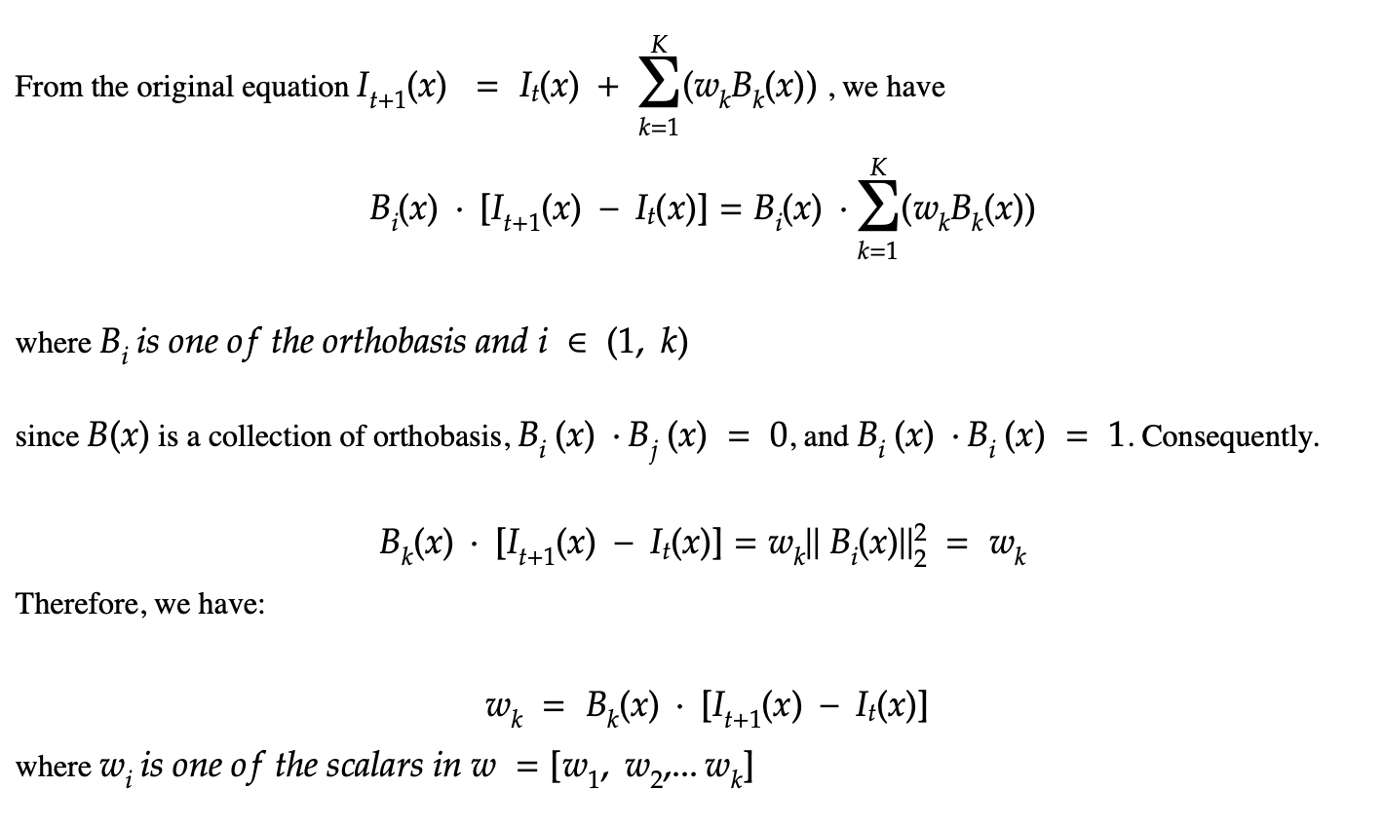

6: Q2.2

Function implemented.

Note: that the it takes 20+ minutes for me to finish tracking all the frames.

7: Q2.3

Note: that the it takes 30+ minutes for me to finish tracking all the frames.

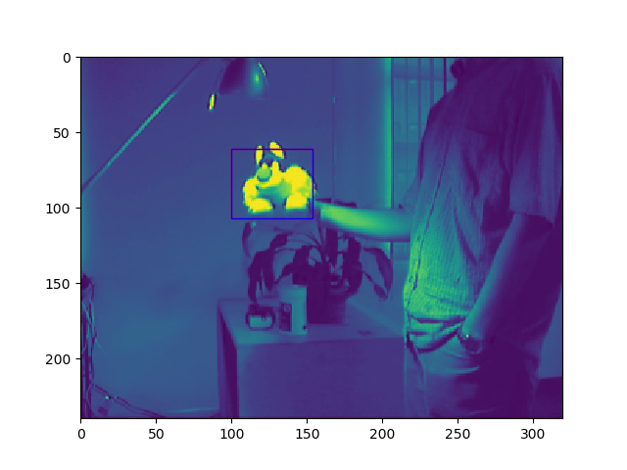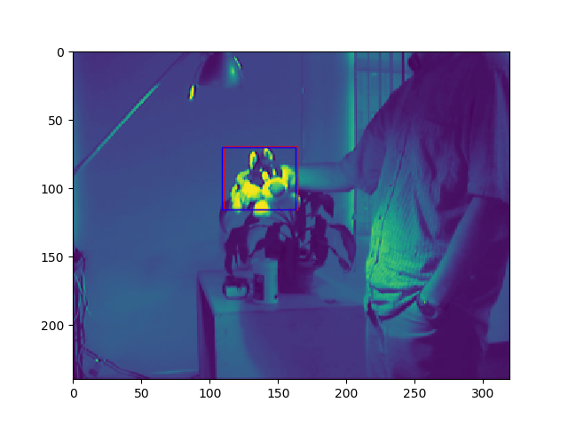

*figure 2.3.1 Frame 1 and 200 using Lucas-Kanade with appearance bases (blue) versus without appearance bases (red)*

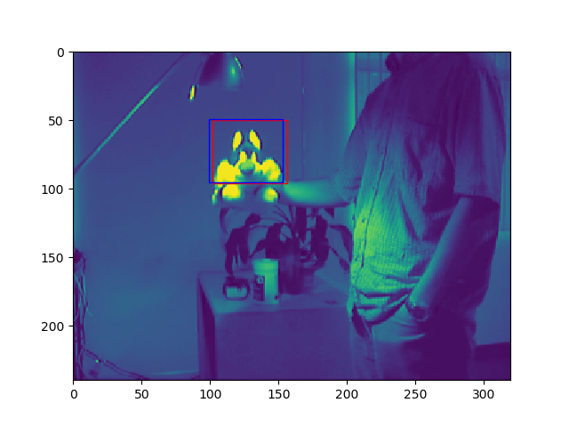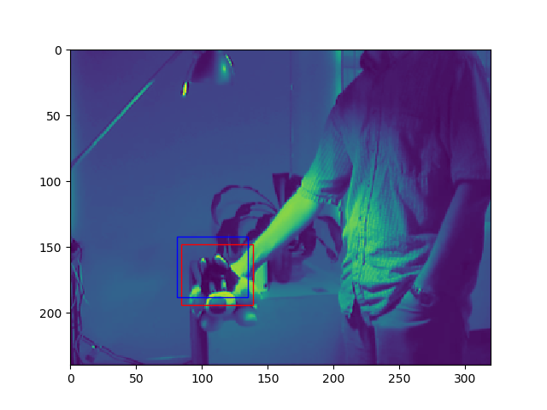

*figure 2.3.2 Frame 300 and 350 using Lucas-Kanade with appearance bases (blue) versus without appearance bases (red)*

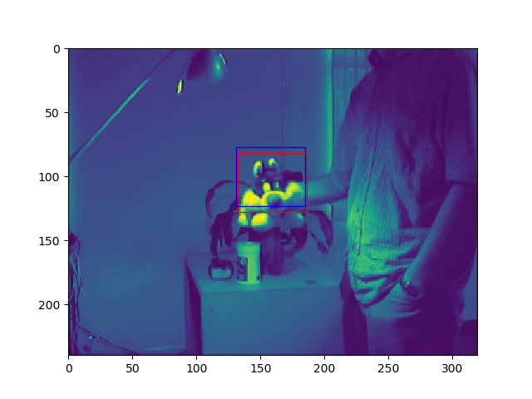

*figure 2.3.3 Frame 400 using Lucas-Kanade with appearance bases (blue) versus without appearance bases (red)*

8: Q3.1

Function implemented.

9: Q3.2

Function implemented.

10: Q3.3

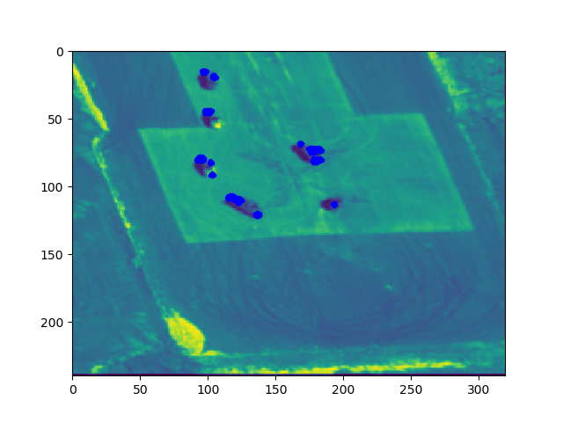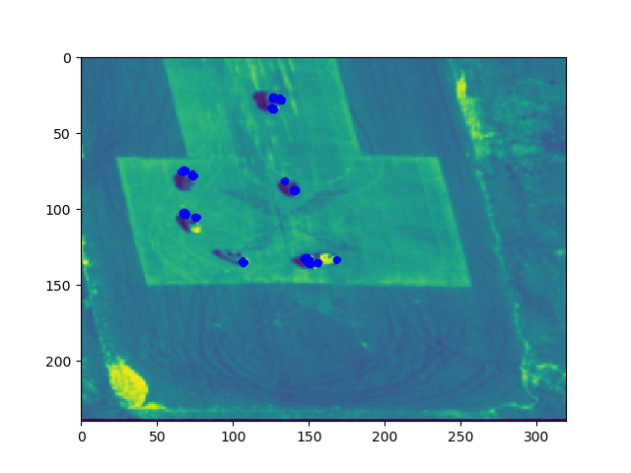

*figure 3.3.3 Frame 30 and 60 using motion estimation and object detection*

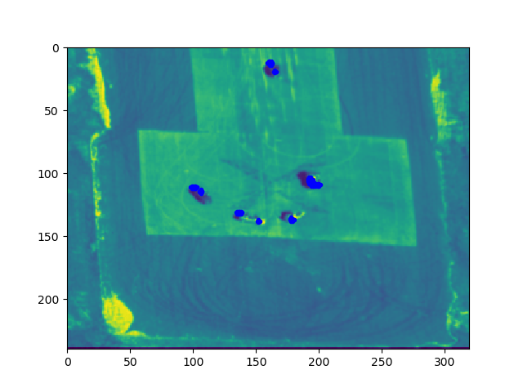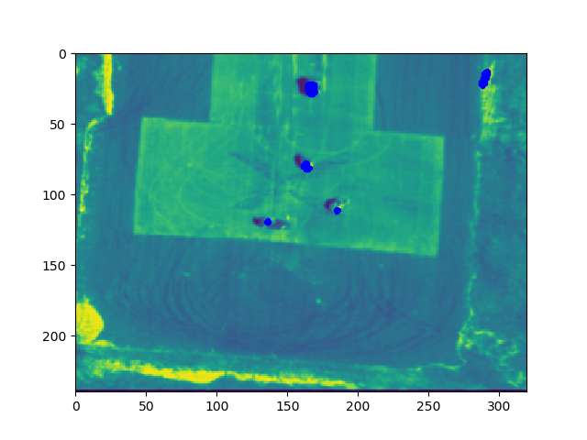  
*figure 3.3.3 Frame 90 and 120 using motion estimation and object detection*

11: Q4.1

Function implemented. Tracked images will be saved as .png image in the current folder

